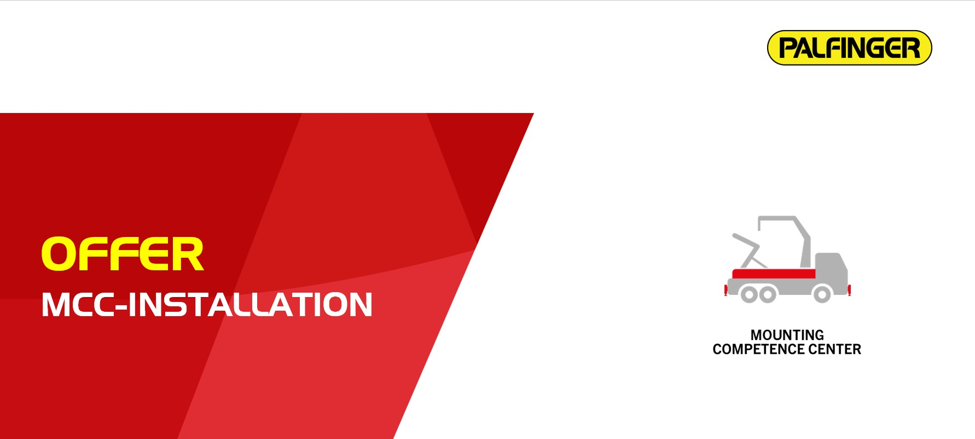

Your Reference |  | Our Reference
Your request |  | MCC23421_OFFER_v01.docx
 |  | CIT-11-01-200
 |  | Budgetary offer
Special information
Budgetary offer for concepts for the African Market, non-CE
Short description
Crane | PK 23500 with LKW-GG, front mounted
Truck | MAN TGS, Volvo FMX, Renault 380
Type | Top mounted platform

This offer contains 4 pages

Crane- and stabilizer installation
CR-30-LKW-F | Raw installation PK-crane 18-30mt, LKW-base, front
Crane installation:
- Positioning and installation of the crane onto the provided truck, in accordance with the crane and vehicle manufacturer's installation guidelines

Subframe and side plates:
- Delivery and installation of a PALFINGER subframe
- Delivery and installation of individual side plates
- Priming and painting of all steel components according PALFINGER standard, max. 1 colour
- Top-coat painting in RAL standard colour

Hydraulics:
- Installation of a provided hydraulic pump (PTO must be available on the truck for the installation of a hydraulic pump)
- Delivery and installation of the hydraulic piping between provided hydraulic tank, oil cooler, crane and pump
- Filling with PALFINGER hydraulic oil PREMIUM 32

Electrics:
- Installation of the electrical connection between crane and vehicle with customized cable harness
- Parameter setting of the vehicle for crane operation

Functional check:
- Adjustment of the pump
- Palcheck crane
- Functional check for crane and final inspection of the vehicle
Displacements and Chassis adaptions
DISPLACE-00 | Without adaptions and displacements
- Without any chassis adaptions
- Without any displacements like airtanks, APM, hydrodrive, etc.
Platform
PLAT-1101 | PALFINGER top mounted platform - Eco
customized | Installation of platform with side and tail boards acc. following specification:  - Dimension 6.245x2.471x600 mm  - Height of front board 1.000 mm  - Height of side and tail boards 600 mm  - Boards made of steel profiles 33mm  - all steel parts sandblasted, primed and painted  - Side boards divided in two parts, foldable and detachable  - rear wall foldable and detachable  - middle and rear pillars detachable  - all walls with rubber stop when opened  - Floor made of steel  - Lashing point only in the side frame of the platform (app. all 200 mm)  - step up in side wall at the left rear side

CONT-STD | Container-lock rigid
customized | - Two pairs of JOST-container locking mechanisms for ISO-container  - mounted on extensions lateral on the subframe, with recesses in the platform

Add-on parts
GUARD-01 | Plastic one axle mudguard; black
ADD-ON-00 | Without other add-on-parts
customized | Follow parts are in scope of delivery of the truck manufacturer:  - rear underrun protection  - side underrun protection
Boxes and trays
BOX-00 | Without Toolboxes
 | - Without any boxes or other trays
Approvals and hand over
TRAIN-00 | Without training
 | - The training and handover to the end customer, according to PALFINGER handover directive, is the responsibility of the respective dealer
APP-00 | Without approvals
 | - Without any approvals, registrations or road licensings

Price basis agreement:
- Typing and description errors as well as technical examination and feasibility reserved.
Depending on the final vehicle design, details of this offer may still change.
- If not explicitly stated in the offer, without any changes, relocations, adjustment or customer brand work on the vehicle. (steering, track, brakes, etc.).
- RAL standard colours do not include RAL 9006 and any metallic colours.
- Crane accessories such as stabilizer plates with brackets, additional stabilizers, pumps, hydraulic tanks, PA parts etc. are provided by the custumer.
- The truck will be provided and collected in MCC-plant by the customer at no charge for PALFINGER. The truck must arrive at the factory 3 weeks before the start of assembly, the crane 1 week before. In the event of late provision, we will redefine the delivery date.
Please note: The truck can be transferred between the assembly plants by axle as part of the PALFINGER mounting process. PALFINGER will bear all transfer costs including insurance. PALFINGER explicitly points out that there is no entitlement to compensation for kilometer-dependent truck wear and tear by the customer/dealer!
- After the "design freeze" date has passed, no further changes are possible. The date will be announced in the course of scheduling and in the MCC-dealer sheet.
Price conditions: | net, duty unpaid in EURO, price does not including VAT
We only contract and deliver on basis of our general terms and conditions. The general terms and conditions are issued at our Homepage www.palfinger.com or can be provided on demand.
Sincerely
PALFINGER Europe GmbH

