SCANIA
 | R 500 B8x2*6NB CHASSIS FOR MOBILE CRANE TYPE PLADRIVE 270-271
 |  |  | 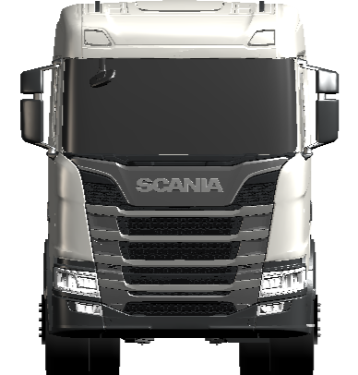 | 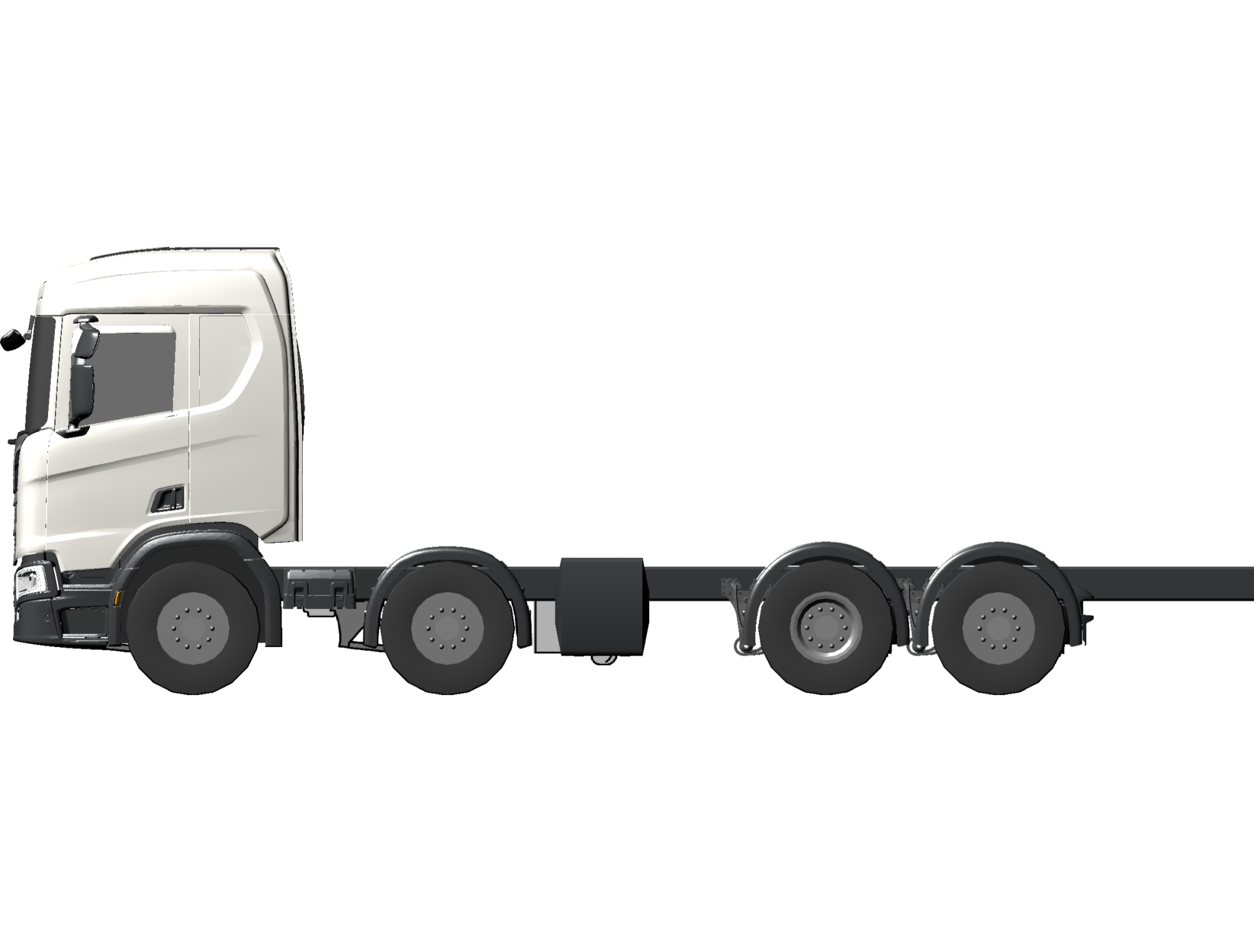
 |  | Guided Offering
 |  | Initial selections
 |  |  | Application |  | Mobile crane | 02758BC
 |  |  | Operation |  | Regional | 02759B
 |  |  | Cab type |  | CR20N | 00889FT
 |  |  | The R-series sleeper cab with normal roof height offers a spacious driver area enabling an optimum driving position. It has very good spaces for storage and installing extra equipment in the cab and can be equipped with up to two beds. The height of the cab is 1,695 mm from floor to ceiling in the centre of the cab. Amongst other things, the cab is suitable for medium distance haulage assignments. Customer benefits Plenty of space for storage or extra equipment. Space for up to two comfortable beds. A safe workplace, because the cab is designed as a large safety cage around driver and passenger. The cab is certified in accordance with ECE-R 29.03.
 |  | General
 |  | Type
 |  |  | Chassis adaptation |  | Basic | 01163B
 |  |  | Wheel configuration |  | 8x2*6 | 00448P
 |  |  | Chassis height |  | Normal | 00272B
 |  |  | Suspension system |  | Air front + Air rear | 00828B
 |  |  | Steering wheel position |  | left hand | 00403B
 |  | Certificates and plates
 |  |  | WVTA, Whole Vehicle Type Approval according to EC |  | Incomplete | 04049B
 |  |  | Plate language |  | German | 00003C
 |  | Dimensions
 |  |  | Chassis width |  | 2550 mm | 00058E
 |  |  | Max truck height |  | 4 meters 96/53/EG | 03239A
 |  |  | Axle distance |  | 4950 mm | 01406JN
 |  |  | Dimension JA/BEP L020 (Bodywork Exchange Parameters) |  | 3350 mm | 01537MX
 |  |  | Bogie distance rear axle 1-2 |  | 1350 mm | 05737E
 |  |  | Steering angle 1st, RH turn |  | 34 max | 01345BB
 |  |  | Steering angle 1st, LH turn |  | 34 max | 01346BB
 |  | Weights
 |  |  | Legal weight 1st axle |  | 9000 kg | 02751E
 |  |  | Legal weight 2nd axle |  | 9000 kg | 02752E
 |  |  | Legal weight 3rd axle |  | 11500 kg | 02753GE
 |  |  | Legal weight 4th axle |  | 8300 kg | 02754DC
 |  |  | GVW legal |  | 32000 kg | 06175KY
 |  |  | GVW technical |  | 39000 kg | 06177NQ
 |  |  | Gross Train Weight, GTW Legal |  | 40000 kg | 00771DA
 |  | Engine
 |  | Engine
 |  |  | Propulsion |  | combustion engine | 04034A
 |  |  | Fuel |  | Diesel | 00520A
 |  |  | Emission level |  | Euro 6 | 02471J
 |  |  | Engine type |  | DC13 165 500 hp Euro 6 /Japan Emission 2016 | 00408TH
Engine type: Straight 6-cylinder diesel engine
Displacement: 12.7 dm³
Max. output at 1800 rpm: 500 hp (368 kW)
Max torque at 925-1340 rpm: 2550 Nm
 |  | SCR, Selective Catalytic Reduction | with | 03488A
 |  | NOx control | With | 03636A
 |  | Torque reduction NOx-control | With | 03719A
 |  | Oil level indication | With | 03829A
 |  | Noise suppression | 81/82 dBA R51.03 | 00472AF
 | Air intake
 |  | Air intake | front | 02253E
 |  | Cab air filter type | normal | 08400A
 | Cooling system
 |  | Coolant freeze point | Freezing point -25 degrees Celsius | 03925A
 | Exhaust system
 |  | Exhaust silencer execution | Compact | 01967D
 |  | Exhaust outlet, direction | right hand | 00392E
 |  | Silencer length | 623 mm | 04329B
 |  | Exhaust silencer longitudinal position (XM) | 4626 mm | 04810K
 | Gearbox
 | Gearbox
 |  | Gearbox | GRS905R | 00017TD
12+2-speed gearbox with range change and splitter gear, 2 crawler gears, 2 reverse gears and retarder.
 |  | Gear selector position | Steering wheel | 03574B
 |  | Oil cooling for gearbox | with | 00387A
 |  | Refrigerant oil cooler gearbox | Refrigerant liquid | 02123B
 | Opticruise
 |  | Opticruise | With | 02519A
Scania Opticruise is an automatic gear changing system for manual gearboxes.
 |  | Performance modes | Economy, standard, power | 05112A
 |  | Kickdown | With | 04370A
 |  | Starter interlock gearselector | With | 05735A
 | Clutch
 |  | Clutch system | automatic | 03575B
Automatic clutch control, together with Opticruise, gives a completely automated shifting system.
 | Axles
 | Front axles
 |  | Axle weight front, technical | 2 x 9000 kg | 00073Y
 | Rear axles
 |  | Bogie weight, technical | 21000 kg (12700 + 8300) | 00552AN
 |  | Rear axle gear | R780 | 00021AK
 |  | Rear axle gear ratio | 2,92 | 00022AZ
 |  | Differential lock | with | 00020A
 | Tag axle
 |  | Tag axle lift | with | 00086A
 | PTO
 | Clutch independent PTO
 |  | Power Take-Off ED | ED120P | 04827B
ED120P is a pre-installed engine power take-off located at the rear end of the engine. It is designed for direct-mounted equipment. Ratio: 1:1.19. Max. torque: 600 Nm, 200 Nm for a vehicle with Opticruise while driving.
 |  | PTO ED electrical preparation | with 1 circuit | 03543A
 | PTO
 |  | PTO EG rear type | EG650P | 06392AJ
The EG650P is mounted on the right-hand side of the gearbox at "5 o'clock". The power take-off rotates anticlockwise, seen from the rear, and is designed for direct-mounted equipment with connection DIN 5462. Ratio: 1:1 with low split and 1:1.24 with high split. Max. torque 1300 Nm.
 |  | PTO-EG electrical preparation | 1 connection | 03502C
 | Fuel tanks
 | General
 |  | Fuel tank, left hand side | 300W aluminium | 02626WD
 |  | Fuel tank location | Normal | 01368B
 |  | Fuel filler cap | lockable | 00518A
 |  | Fuel label according to EC | with | 07462A
 |  | Fuel heater | with | 00557A
 |  | Fuel splash protection | With | 03974A
 | SCR tanks
 |  | SCR heating system | With | 04287A
 |  | SCR reductant tank volume side RHS | 47 dm3 | 04318A
 |  | SCR reductant tank filler cap | Lockable | 04334A
 | Chassis
 | Frame
 |  | Frame, type | F957 | 00458L
 |  | Body attachment bracket, front set | bracket vertical reinforced | 03303K
 |  | Bodywork holes configuration frame | entire frame length | 07432A
 |  | Frame reinforcement rearwards | normal | 08391A
 | Steering
 |  | Front axle steering system type | hydraulic | 07281B
 |  | Steering system backup | hydraulic | 07651A
 |  | Steering force 70/311/EEC | With | 01367A
 |  | Manoeuvrability according to 97/27/EC | Yes | 02127A
 |  | Steering wheel type | basic | 02153A
 |  | Adjustable steering wheel | tilt + slide | 02991C
 | Suspension front
 |  | Air spring height, front | Low | 01334B
 | Suspension rear
 |  | Air suspension rear type | 2-spring | 03226A
 |  | Shock absorber rear axle | With | 02259A
 |  | Level adjustment speed | Fast | 02487F
 |  | Level adjustment control truck/trailer | Truck | 04029A
 |  | Alternative predefined chassis levels | exhausted bellows + 2 memory | 02488F
 |  | Load transfer according to EC 97/27 | yes | 02972A
 |  | Load limit | at 11500 kg | 00084D
 |  | Load transfer | with | 01353AA
 |  | Load transfer, tag axle position | always down | 01528A
 |  | Load transfer limit | 14900 kg | 06028F
 |  | Load transfer manoeuvring | max load transfer request | 06029B
 |  | Speed limitation for load transfer | 30 km/h | 01911D
 |  | Axle load display | Front and rear | 02478A
 | Anti-roll bar
 |  | Anti-roll bar, front | Extra stiffness | 00092D
 | Electrics
 |  | Battery | 230 Ah | 00095AM
 |  | Battery position | Left hand side | 03979A
 |  | Alternator charge | 100 A | 01122D
 |  | Battery master switch manoeuvring | Double acting left side frame | 02410D
 |  | Preparation for toll collect | with | 03501A
 | Wheels & Mudguards
 | Tyres
 |  | Tyre type front axle | 385/65R22.5 Regional Steer Bridgestone Duravis R-STEER 002 EVO | 08905MQ
 |  | Tyre type rear axle | 315/80R22.5 Regional Drive Bridgestone Duravis R-DRIVE 002 | 08906LG
 |  | Tyre type tag axle behind drive axle | 385/65R22.5 Regional Steer Bridgestone Duravis R-STEER 002 EVO | 08908MQ
 | Rims
 |  | Rim type front axle | 22.5 x 11.75 steel | 05001FA
 |  | Rim type rear axle | 22.5 x 9.00 steel | 05002DA
 |  | Rim type tag axle behind drive axle | 22.5 x 11.75 steel | 05004FA
 | Wheel equipment
 |  | Wheel nut cover | steel stainless | 00148B
Wheel nut caps in stainless steel.
 |  | Sticker wheel nut retight | German language | 03688C
 |  | Wheel chock | 2 pieces | 01233B
 | Mudguard front
 |  | Front mudguard size | 675 mm | 05071B
 |  | Spray-suppression according to EU 109/2011 | With | 05828A
 |  | Spray suppression | with | 01421A
 |  | Mudflap, front | with | 00053C
 |  | Mudguard second front axle | With | 04050A
 | Mudguard rear
 |  | Mudguard rear | with | 00164A
 |  | Rear mudguard execution | High top | 00514B
 |  | Rear mudguard, position | Normal | 01977A
 |  | Mudflap rear | with | 06632A
 |  | Mudflap rear material | Plastic | 02331A
 | Brakes
 | Brake system
 |  | Brake category | AB | 01493AB
 |  | Brake adaptation | Rigid | 00039B
 |  | Wheel brake | disc | 01405B
 |  | Brake control combination | electronic with disc brake | 02647B
 |  | Hill hold | hill hold | 03485C
 |  | APS, Air Processing System | Air management | 02458B
 |  | Parking brake system | pneumatic | 06171A
 |  | Parking brake trailer control | braked by service line | 05848A
 | Wheel brakes
 |  | Brake chamber type 1st front | membrane + spring | 00028B
 |  | Brake chamber type, 2nd front | membrane + spring | 00005B
 |  | Brake chamber type, 1st rear | membrane + spring | 00008B
 |  | Brake chamber type trailing tag axle | membrane + spring | 01175B
 | Auxiliary brakes
 |  | Retarder type | R3500 | 04579A
 |  | Auxiliary brake control | manual + automatic | 06302C
 | Body and chassis adaptation
 | Rigid
 |  | Closing crossmember | with | 01557C
 |  | Closing crossmember profile | U-profile 5 mm | 04341A
 | Bodywork interface
 |  | Bodywork Communication Interface, BCI | with | 05837A
 |  | Bodywork info in Instrument Cluster | With | 03888A
By means of lamps, sounds and display messages in the instrument cluster the bodywork has many options for providing the driver with information. There is access to 8 lamps, all with the option to indicate with different colours. There are also a number of pre-defined display messages and a total of five different sounds. All information is adapted to Scania's information levels: alarm system, warning, information and status. In order to be able to activate 2 of the 8 positions using sound and colour, the necessary connectors and cable harnesses are fitted at the factory, 03888.For the option to program and activate all 8 positions, BCI control unit, 05837A, and ICL with full functionality, 03888A, must be selected in combination.9 different variants of symbol lens can be ordered via variant code 07331.
 | Symbol lens instrument cluster | general | 07331A
 | Cable harness for bodybuilder | 7+7+7 | 02411F
Three 7-pin cable harnesses from the bodywork's central electric unit routed under the cab.
 | Cable harness for bodybuilder frame | 8 m | 03023D
Eight metre long bodybuilder cable for connection of equipment to the rear of the frame.
 | Remote control engine start | Prepared | 03313B
Prepared for remote control engine starting. Includes extra pressure sensors to check that the parking brake is applied and the gearbox in neutral.
 | Miscellaneous
 |  | Step chassis | with | 03052D
 |  | Registration plate holder rear type | Panel | 04499A
 | Cab exterior
 | Cab general
 |  | Cab suspension | air comfort | 02521G
Air Comfort, with 4-point air suspension, integrated shock absorbers and level adjustment.
 |  | Cab tilting | electrical | 01659A
 | Exterior
 |  | Sun visor, external | without | 00060B
 |  | Chassis boarding grab handle on rear wall cab | with | 08954A
 |  | Horn in front, type | compressed air 118 dB | 05174A
 | Front bumper
 |  | Front Underrun Protection, FUP directive | FUP device | 02398B
 |  | Bumper protrusion | 0 mm | 04932A
 |  | Bumper beam vertical position | high | 05065A
 | Windows
 |  | Windscreen | Untinted | 02313B
 |  | Door window glass type | single | 05084A
 |  | Window, rear wall | without | 00066B
 | Mirrors
 |  | Rear view mirror glass driver side | spherical | 04935B
 |  | Rear view mirror glass passenger side | spherical | 04936B
 |  | Rear view mirror type | A | 04934A
 |  | Rear view mirror casing shape | smooth | 06784A
 |  | Rear view mirror heating | with | 04937A
 |  | Rear view mirror electrical adjustable | passenger and driver side | 05128B
 |  | Wide angle mirror | Driver + passenger side | 02181C
 |  | Close-proximity mirror | manual adjusted | 04938A
 |  | Front view mirror | manual adjusted | 01902B
 | Lock and alarm
 |  | Locking type cab | remote central locking | 05123C
 |  | Frequency remote lock | 433 MHz | 03889A
 |  | Number of keys/remotes | Two | 02343A
 |  | Immobiliser | With | 02344A
 | Lamps
 |  | Headlamp type | H7 | 02983E
 |  | Dipped beam automatic | with | 05058A
 |  | Headlamp asymmetry | Right hand | 00474A
 |  | Daytime Running Light, DRL function | With LED DRL + position lamps | 03908B
 |  | Headlamp cleaning | With | 02416A
 |  | Fog lamp front type | LED 3 diods | 06044C
 |  | End outline marker lamp | White | 01313A
 |  | Side marker lamps | Temporarily mounted | 00313B
Amber-coloured side marker lamps with light-emitting diodes, temporarily fitted on the frame. The bodybuilder or other workshop must fit them in accordance with national legislation in force.
 | Side marker lamp direction indication | with | 07176A
With direction indicators in the side marker lamps. When the driver signals a turn using the direction indicator lever, the side marker lamps flash as well. When the hazard warning signal is activated, the side marker lamps and all direction indicator lamps flash as well.This is a European legal requirement for vehicles more than 9 metres long. Whole Vehicle Type Approval (WVTA) is not met without this.Advantages for the customerSafety: This indicator provides other road users with an earlier warning of forthcoming turns, thereby enhancing safety.
 |  | Taillamp type | Bulb | 03981A
 |  | Taillamp position | on bracket | 01532A
 | Cab interior
 | Seats
 |  | Seat category, driver side | basic | 01431C
Seat with air suspension and integrated safety belt. The following settings are possible: position, height, seat cushion length and backrest.
 | Seat category, passenger side | static | 01432E
Unsprung seat with integrated safety belt. The following settings can be made:
- position
- height
- backrest.
 |  | Seat upholstery driver side | woven | 05028A
 |  | Seat upholstery passenger side | woven | 05029A
 | Beds
 |  | Bed lower | 800 mm, fixed | 06563A
 |  | Bed lower, mattress | foam | 05211B
 |  | Bed lower foam mattress firmness | medium | 07932A
 |  | Bed lower length extension | with | 08557A
 |  | Bed safety net | With | 03686A
 | Storages
 |  | Storage rear lower, driver side | drawer | 05158A
 |  | Storage rear lower, passanger side | drawer | 05159A
 | Interior
 |  | Wall panel and headlining material | vinyl | 02299A
 |  | Door panel | Plastic | 02577A
 |  | Boarding grab handle colour | black | 08081A
 |  | Curtain door & windscreen | preparation | 00143B
 |  | Curtain for bed | with | 00419A
 |  | Protective mats floor | rubber | 02162A
 |  | Mat centre floor | rubber | 02168A
 | Instruments
 |  | Instrument panel finish | hard | 02172E
 |  | Instrument cluster | 4 inch screen km/h | 02301P
Instrument cluster with 4.1" colour display with trip computer and high resolution.
 | Window winder control activation | ignition on or unlocked door | 07411A
 | Tachograph | smart Stoneridge | 02303ES
Smart digital tachograph from Stoneridge that permits remote readout.
 |  | Tachograph data upload | With | 03956A
 |  | Speed limitation | 89 km/h | 06445GJ
 |  | Speed limitation legal | 90 km/h | 06446H
 |  | Adaptive Cruise Control, ACC | With | 03583A
 |  | Scania Lane Departure Warning, LDW | With | 03601A
 |  | Advanced Emergency Braking, AEB | With | 04335A
 |  | Driver attention support | with | 07261A
 |  | Sticker assistance | Ph +492618878888 | 03685DE
 |  | Sticker vehicle towing | German language | 03687C
 | Climate system
 |  | Climate system heating | with | 05208A
 |  | Air conditioning | with | 00097A
 |  | Climate system control | automatic | 02200B
 | Lighting
 |  | Internal lighting | ambient | 04843C
Dome lamps with integrated reading lamp. Boarding lamp. Background lighting by cup holder. Lamps in the roof shelf.Supplementary internal lighting can be added by specifying with variant code family 05974 and 05975.
 |  | Internal light control rear wall | advanced | 08728B
 |  | Background lighting below instrument panel | with | 05974A
 |  | Reading lamp lower bed | Right side | 03758A
 | Communications
 |  | Infotainment system | 2 DIN with 5 inch screen (Advanced) | 05120A
5-inch colour display with touch function.
 |  | Loudspeaker | 2 x 20W | 02176A
 |  | USB IP centre position | USB | 06499A
 |  | CB radio | Prepared with 12V outlets | 00391C
 |  | Communicator | C300 complete | 03808C
 |  | FMS, Fleet Management System preparation | Gateway (interface) | 04019A
 |  | 12/24V sockets | Basic | 05750A
 | Manuals
 |  | Driver´s manual language | German | 06151C
 |  | Driver´s manual extra language | English | 06152A
 | Rescue equipment
 | Rescue equipment
 |  | Emergency hammer | With | 03584A
 |  | Bulb and tool kit | with | 05133A
 | Colour
 | Cab
 |  | Cab paint type | solid | 06527A
 |  | Cab colour white | Ivory White | 06491A
 | Chassis
 |  | Chassis colour grey | Sub Grey | 06778AP
 | Multi Colour Concept (MCC)
 |  | Front grille upper panel colour | Steel grey | 06010C
 |  | Front grille upper ribs colour | Silver brilliant | 06021C
 |  | Front grille lower panel colour | Steel grey | 06022D
 |  | Front grille lower ribs colour | Silver brilliant | 06023D
 | Logistics
 | Market logistics
 |  | Country code | DE - Germany | 01256DE

